**TRAGEDY OF FLIGHT**

**1.INTRODUCTION**

An airplane crash analysis is a detailed investigation into the causes of an aviation accident. The goal of an airplane crash analysis is to identify any factors that contributed to the accident, with the ultimate goal of improving safety and preventing future accidents. The process of conducting an airplane crash analysis typically involves the collection and analysis of a wide range of data, including information about the aircraft and its systems, the operators, and any other relevant factors. This data is typically collected from Kaggle. Once the data has been collected, it is analysed through tableau, to identify any potential causes of the accident. The results of an airplane crash analysis are typically published in a report, which may include recommendations for improving safety and preventing similar accidents in the future. These recommendations may be implemented by the relevant authorities or industry organizations.

**2.PROBLEM DEFINITION AND DESIGN THINKING**

**2.1 Empathy**

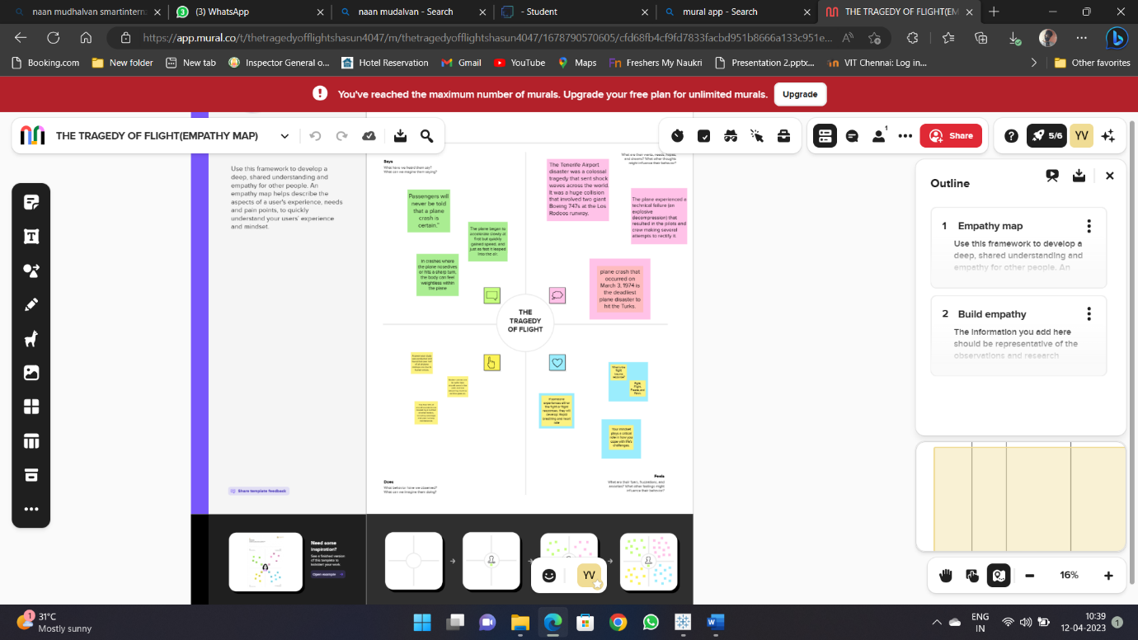

**2.2 IDEATION AND BRAINSTORMING MAP:**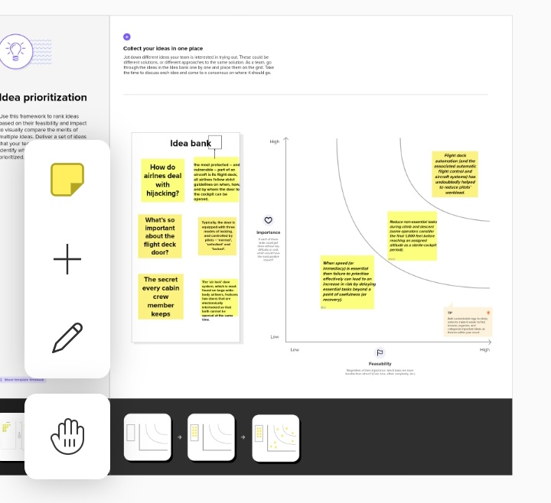

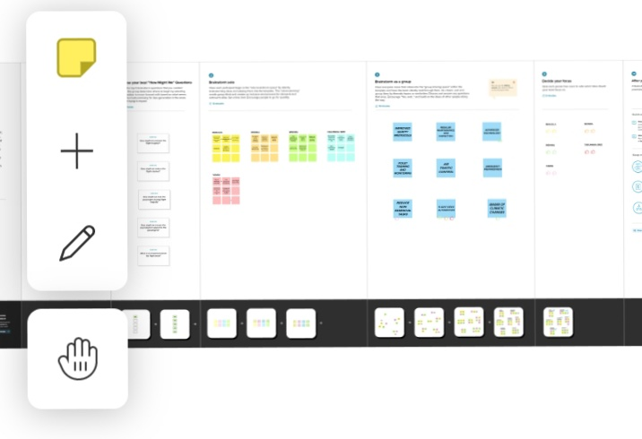

**3.RESULT**

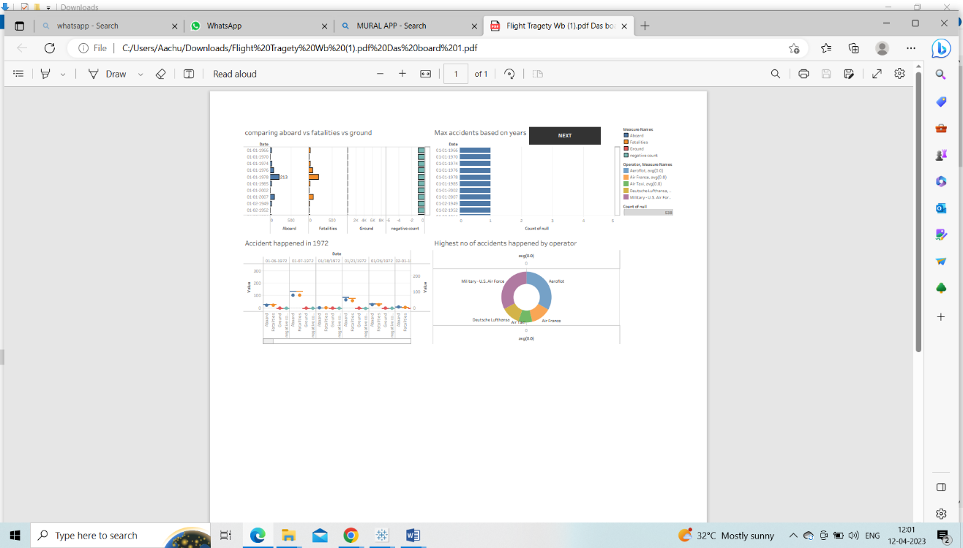

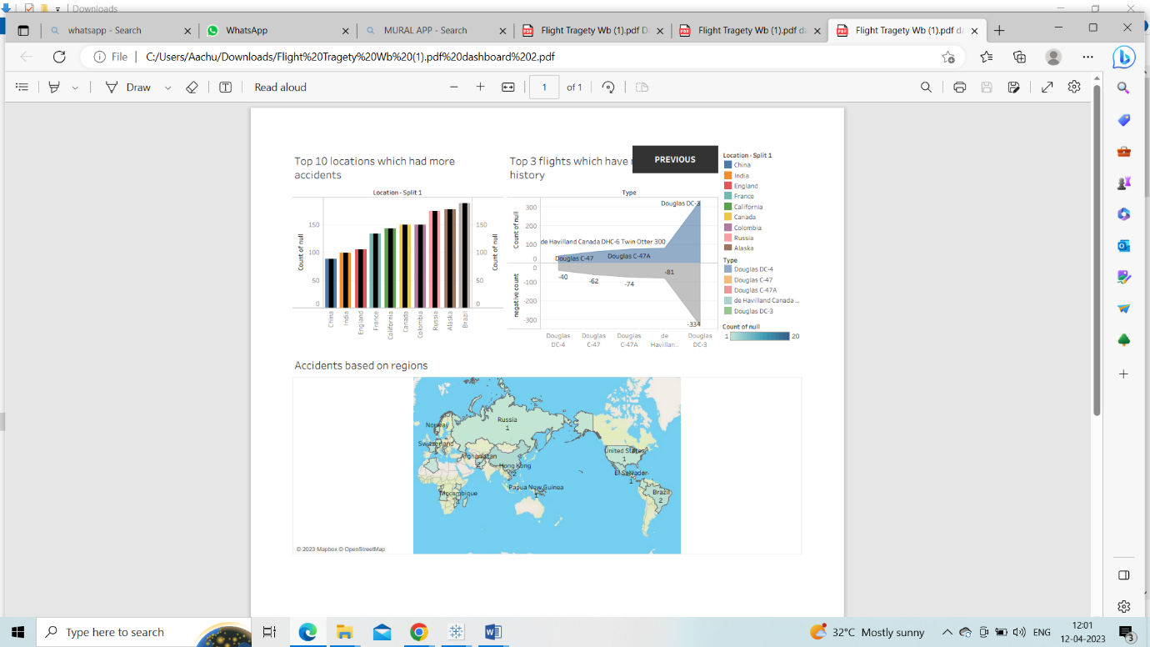

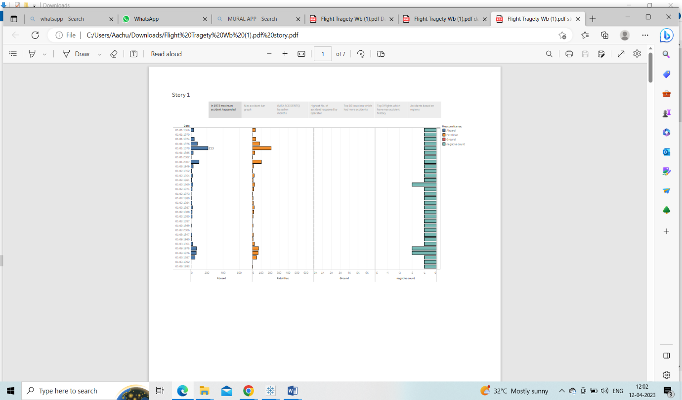

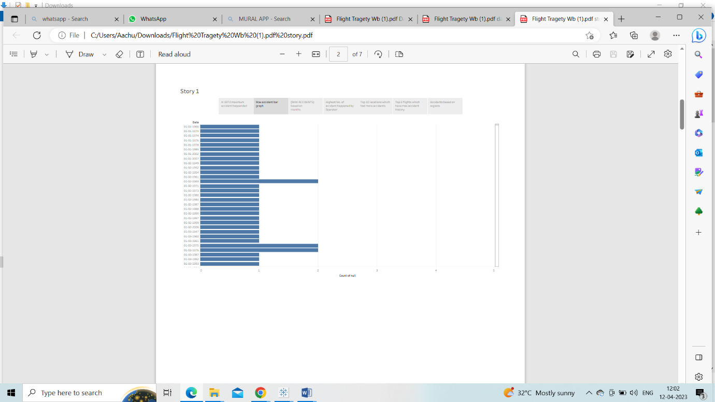

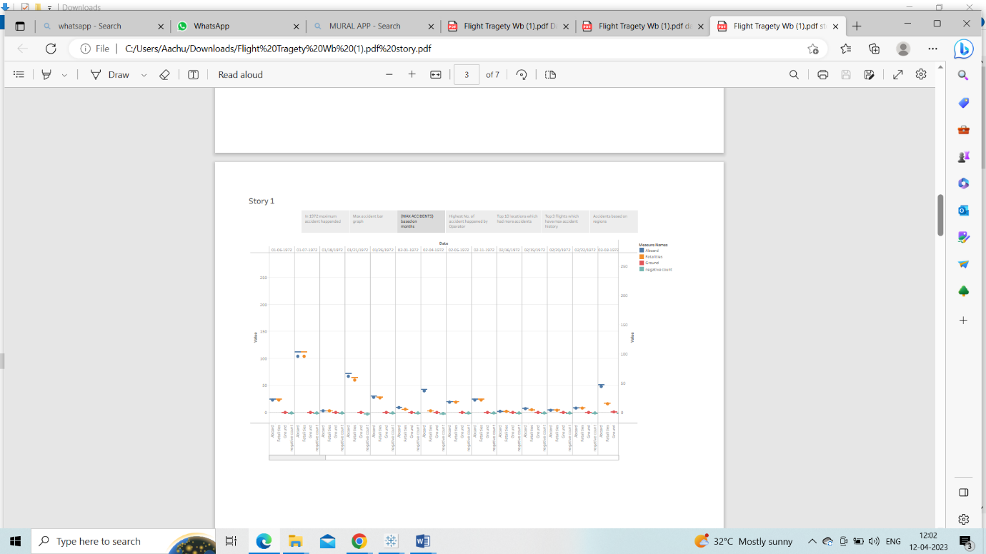

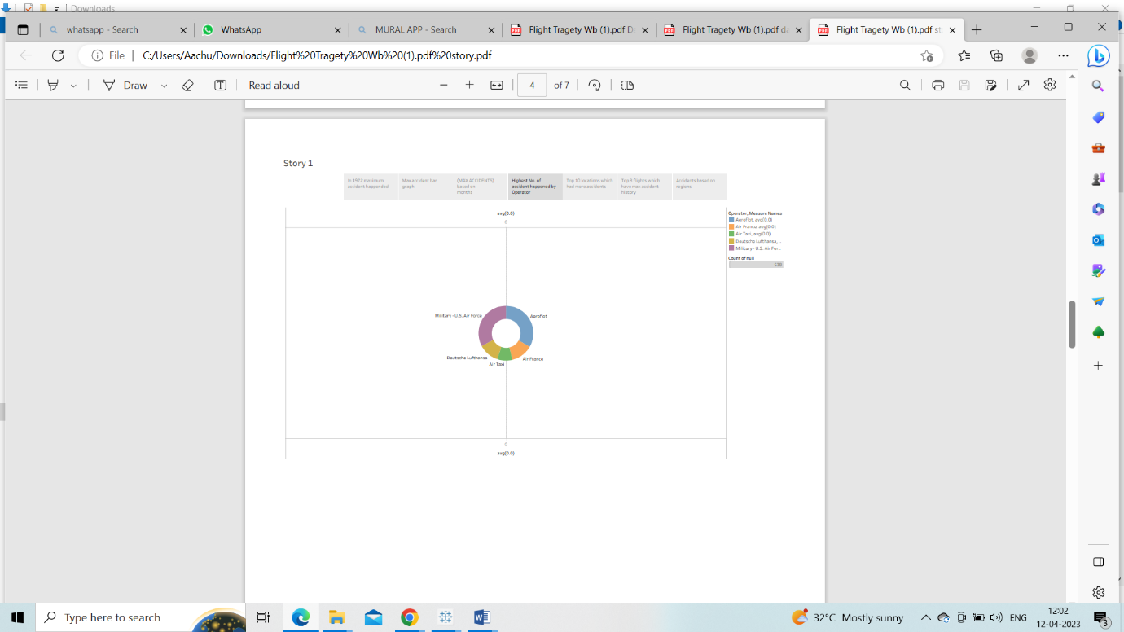

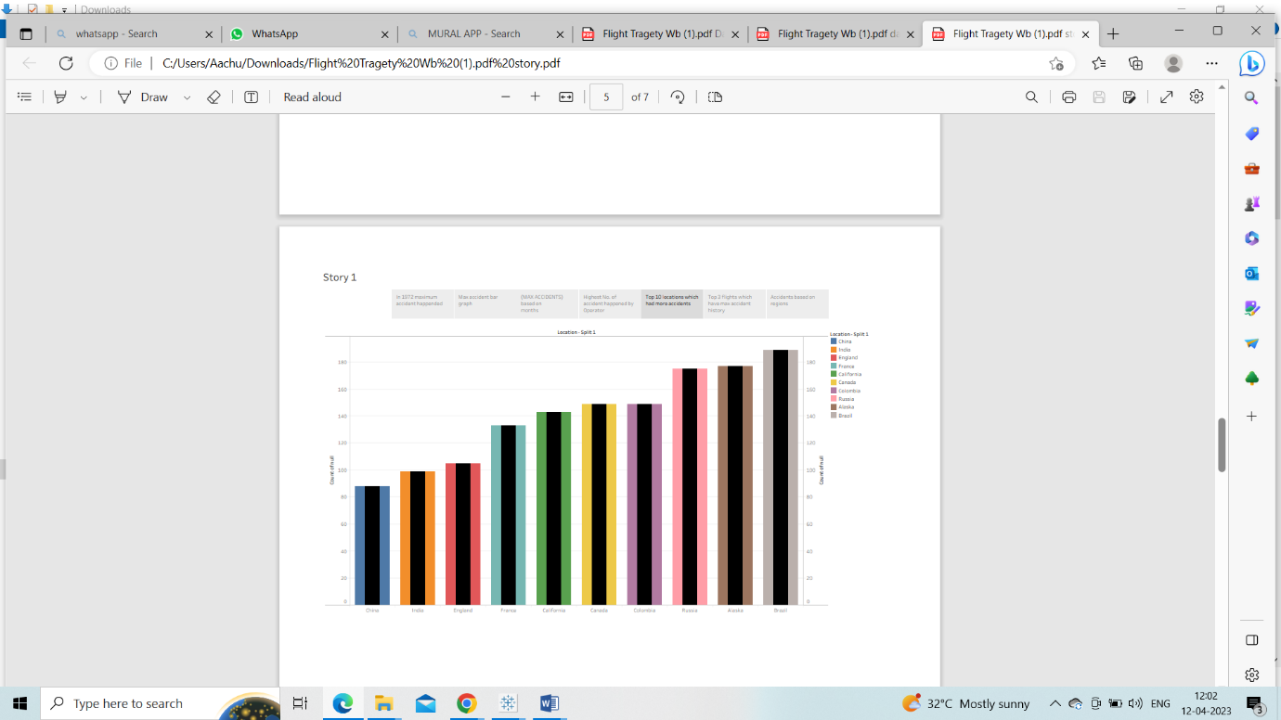

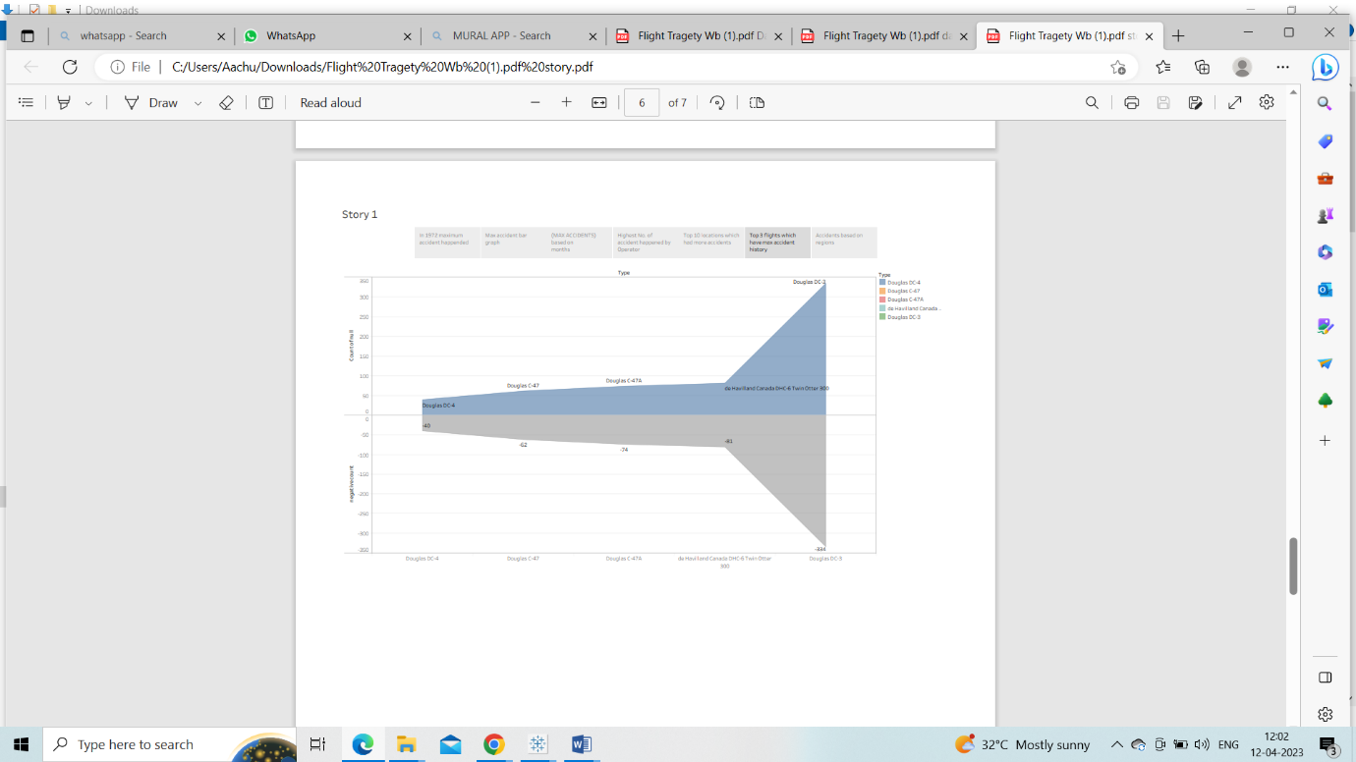

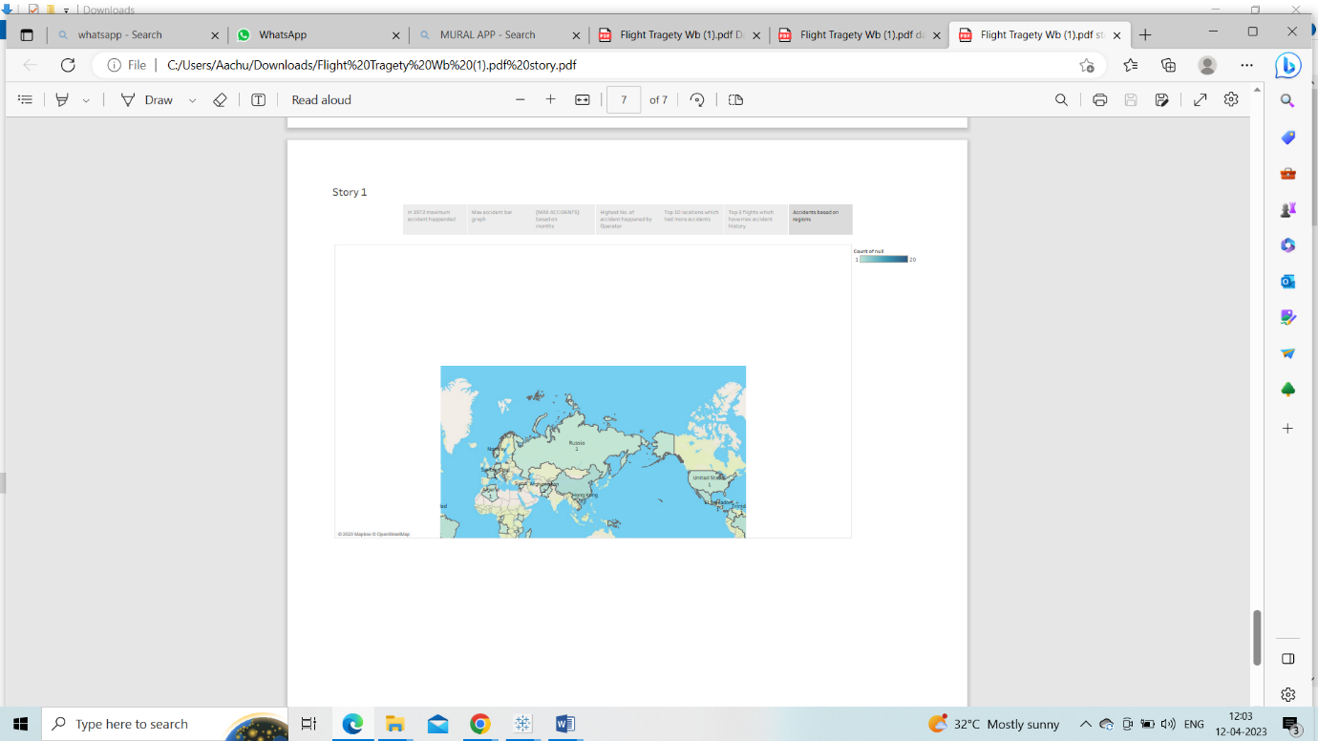

**4.ADVANTAGES AND DISADVANTAGES**

Advantages of traveling by air plane.  
The biggest advantage of flying is that it is often the fastest way to get from one place to another, especially when long distances are involved. It helps us save a lot of time, so we can do more things.  
Secondly, I think the comfort of air traveling makes people satisfactory. When traveling by air, we can sit comfortably in an arm- chair, reading magazines or watching a free film on television. The process of making arrangements to fly can be quite convenient. A plane ticket can be purchased by telephone or on the Internet. We don’s have to cope with crowed at air port as other stations for buying tickets.  
Disadvantages of traveling by air plane.

First of all, Flying is often the most expensive form of transportation, especially if reservations are not made well in advance. Some people might not be able to afford to fly on the budget [airline](https://www.studymode.com/subjects/airline-page1.html).  
Then air travels have the reputation of being dangerous and even hardened travellers are intimidated by them. There are plane crashes in which the crew and passengers have died to a man.  
Finally, traveling by air, we can’t stop wherever we want to enjoy beautiful landscapes on our way as we do in a trip by car or boat.

**5.APPLICATION**

The**horizontal projection of the terminal area** is usually not a circular**area** but**a** polygon whose boundary is connected by n coordinate points. Therefore, it is necessary to determine whether the flight path is**divided in the terminal** flight**area.** The method is used to solve this problem

**6.CONCLUSION**

From this flight clashes analysis we conclude that 1972 is the year where maximum no .of accidents happened. From this analysis we can also understand few more important information about flight tragedy such as the top 10 location which had more accidents, top 3 flights which have maximum accident history, accidents based on regions and so on …

**7.FUTURE SCOPE**

Clash detection process identifies where the independent models clash with each other- finding where elements from one model overlap the elements of models from other architect-engineering design disciplines. Clash detection ensures every aspect works hand-in-hand and nothing is incompatible

Using new classes of electric, hydrogen and autonomous air vehicles, the ‘Future flight’ challenge will transform how we connect people, deliver goods and provide services. It will speed up the acceptance of these vehicles into service by encouraging businesses to share knowledge and resources.